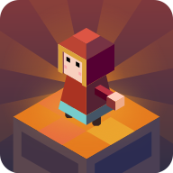

**Step High**

**Thank you for purchasing the asset , if you have any question please contact me at** [**madfireongames@gmail.com**](mailto:madfireongames@gmail.com)

**Project Structure**

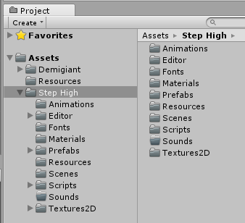

**Animations folder**: There is stored animations used in game.

**Editor Folder**: There is stored Game Design window script (Dont edit anytging in this folder).

**Fonts folder**: There is stored fonts used in GameScene.

**Texture2D**: There is stored all sprites and textures used in game.

**Materials:** There is store material of GameObjects used in game.

**Prefabs Folder**: There is stored Game Objects spawned in game.

**Resources Folder**: There is stored resources for Game Design (Dont edit anytging in this folder).

**Scripts Folder**: There is stored Script files used in game.

**Sounds Folder**: There is stored Musics and Sound effects used in game.

**Scripts**

1. GameManager:- This script controls the game , its saves and loads data from the device eg:- Best Score , musics status ,etc.

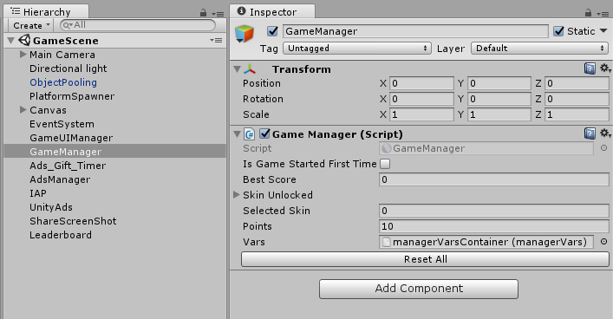

1. Leaderboard:- Scripts which control leaderboard of play store and app store.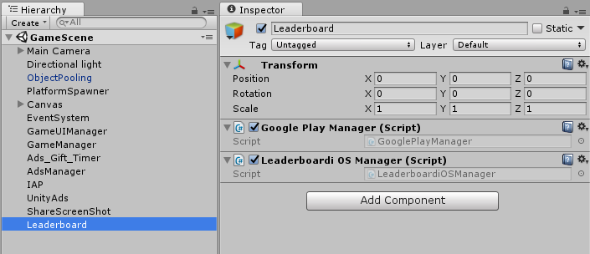
2. Unity IAP:- This script controls the Unity IAP for android and iOS. It controls the remove ads function.

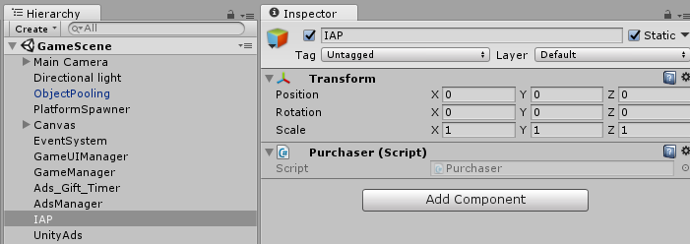

1. GameUI:- This script controls the game menu , is assigns the functions to the buttons and updates the text like score , best score , etc;

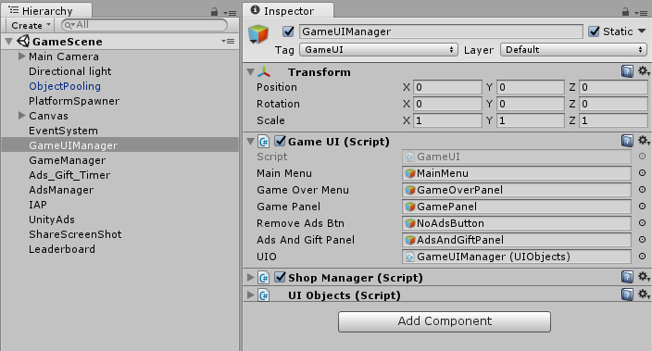

1. ShopManager:- This script controls the shop menu , is assigns the functions to the buttons and updates the character , etc.

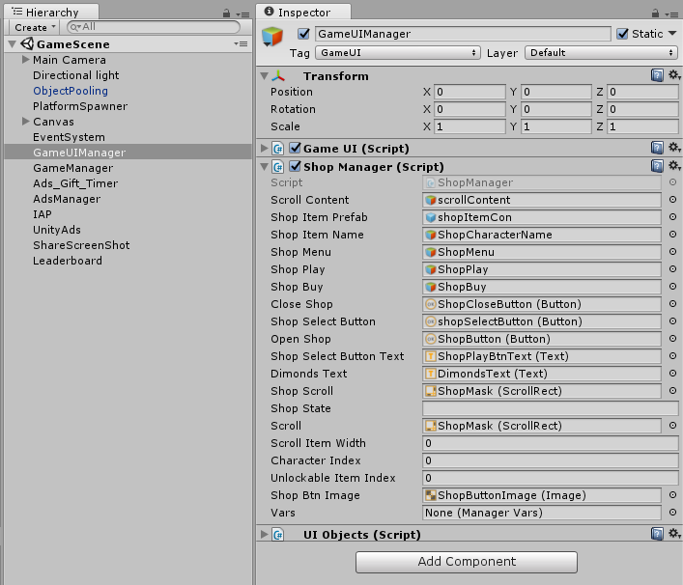

1. UIObject:- This script keep tack of all the elements in the scene like sprites , text , sound , font etc .

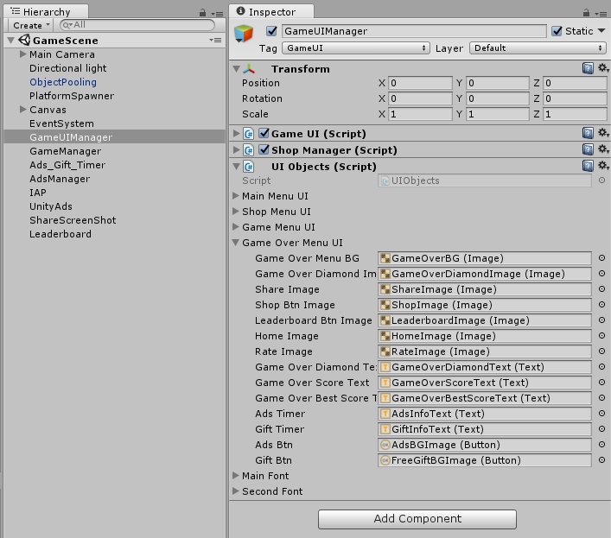

1. ObjectPooling:- This script created the required clone of objects which are used again and again and it the make them active when required , helps in game optimization.

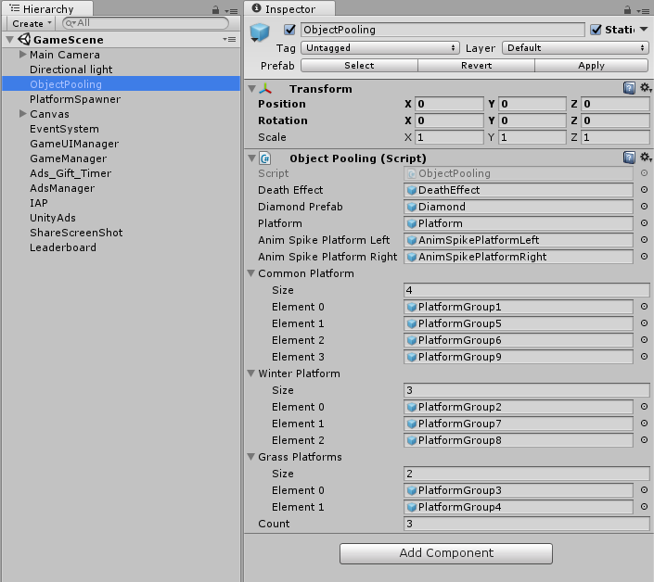

1. ScreenShot:- This script helps player to take the screen shot of their game and share it on the social platforms like facebook , whatsapp , etc.

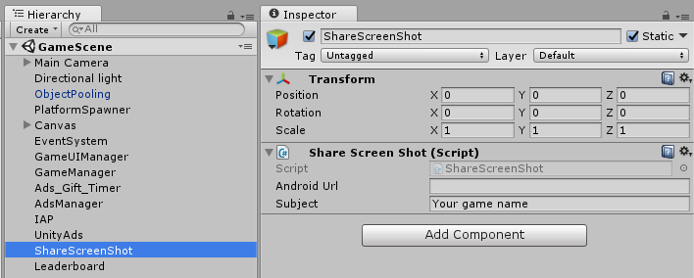

1. PlatformSpawner:- This script controls the spawning of platform , there path , theme and much more.

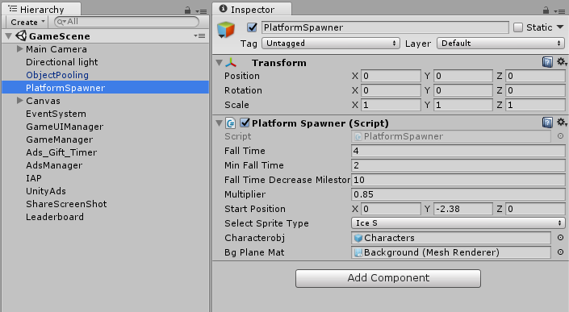

How To Reskin?

Go to Editor -> Click on GameDesign.

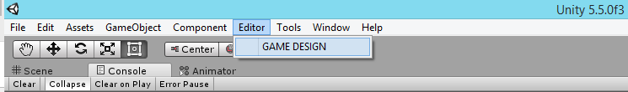

GameDesign window will open.

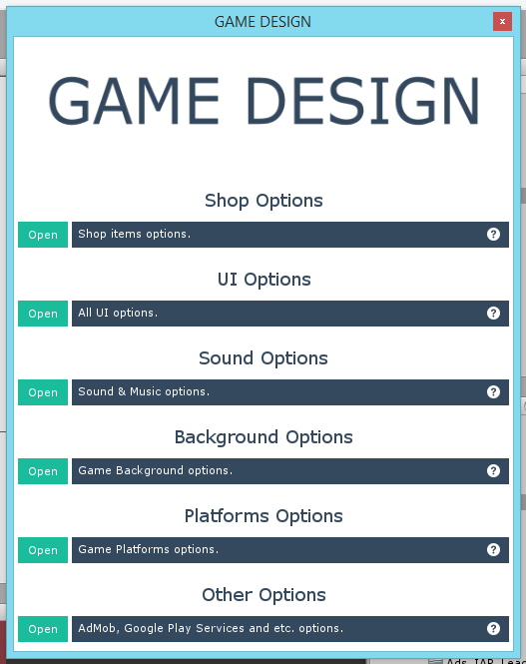

Open any section and you will find fields to change.

**Game Design: UI Options**

You can easily edit all UI Elements like Button sprites, Text colors.

All available configurations is listed bellow:

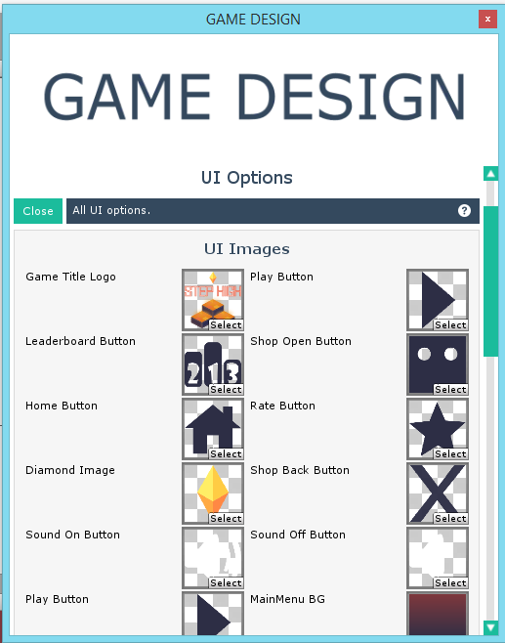

**Game Design: Sound Options / Other Options**

You can easily edit all sounds and musics like characters sound effects, buttons click , admob settings , Leaderboard for iOS and Android , and much more.

All available configurations is listed bellow:

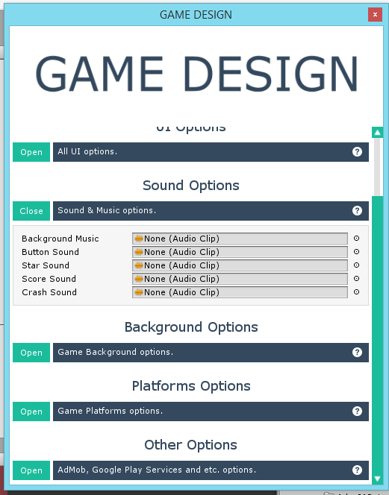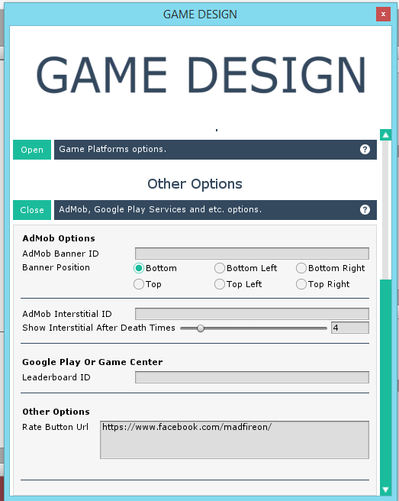

The only thing which you cannot change from here is the sprites of Player , enemies and platform , you will have to do it manually.

**Game Design: Shop Options**

You can easily add or remove the character by editing the shop options. The shop menu is update by its own.

Note:- The size of character image must be 256*256 and the Pixel per unit must be 250

All available configurations is listed bellow:

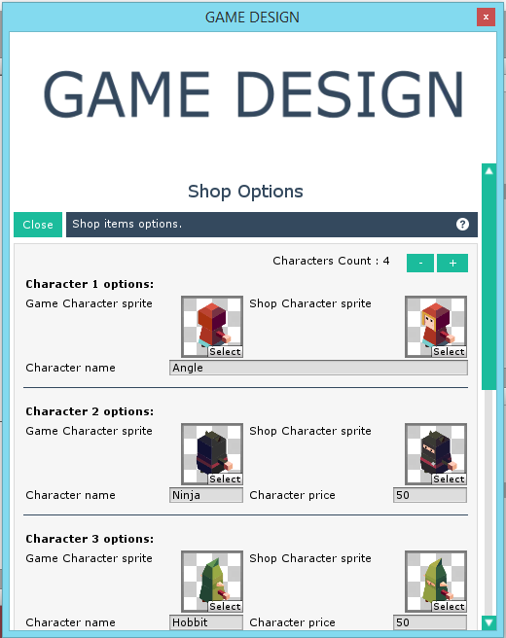

**Game Design: Background Options**

You can easily add or remove the background here

Note:- The 1st 3 brackground are being used in game so if you change the 1st 3 bg they will apear in game , but if you add more bg then you will have to configure the script. The script is documented so you can change it easily.

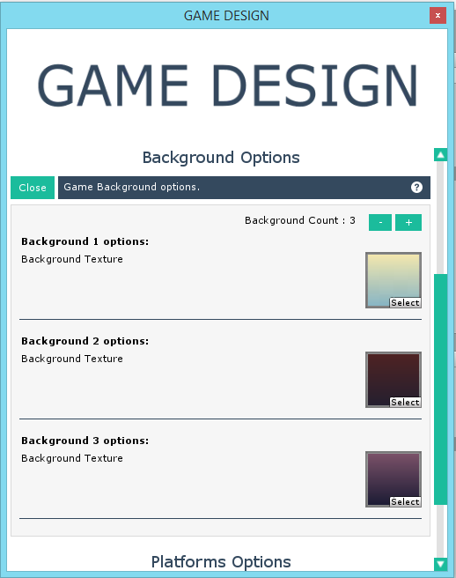

**Game Design: Platform Options**

You can easily add or remove the platformd here

Note:- The 1st 4 platform are being used in game so if you change the 1st 4 platform they will appear in game , but if you add more platform then you will have to configure the script. The script is documented so you can change it easily.

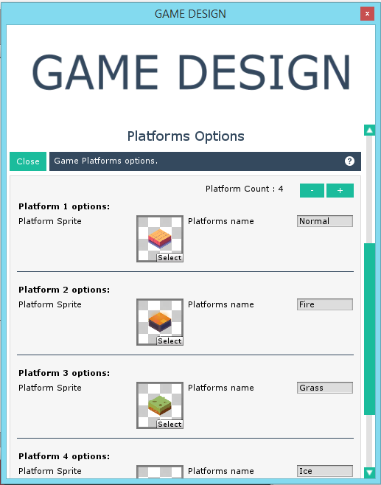

**Want Free Assets?**

**Thank you for purchasing my asset , well we have started our own website where we upload free asset every month. So if you are interested in free asset then check out our site and subscribe to the updates so we can contact you on release of new free asset.**

**Link:- https://madfireongames.com/**